**Fault Ride-Through Strategy for Two-Stage GPV System Enabling Load Compensation Capabilities Using EKF Algorithm**

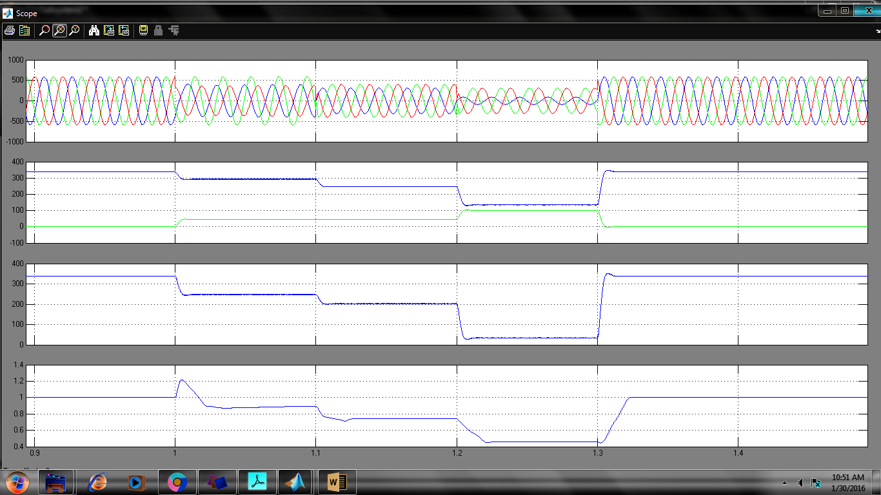

Vsabc, V+ &V-, V+ -V-,Vpu

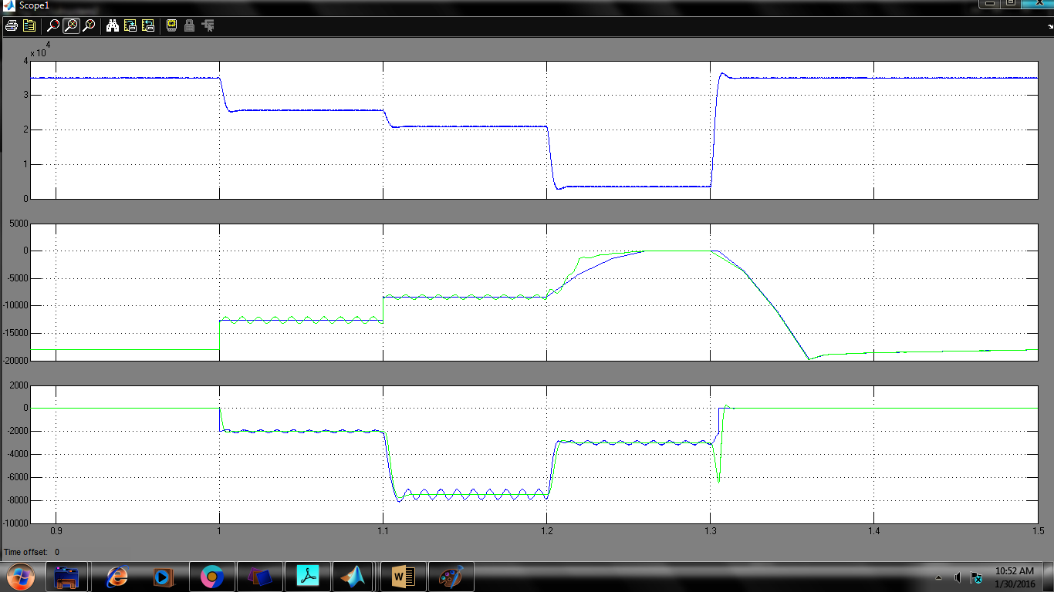

MNp,Pg,Qg

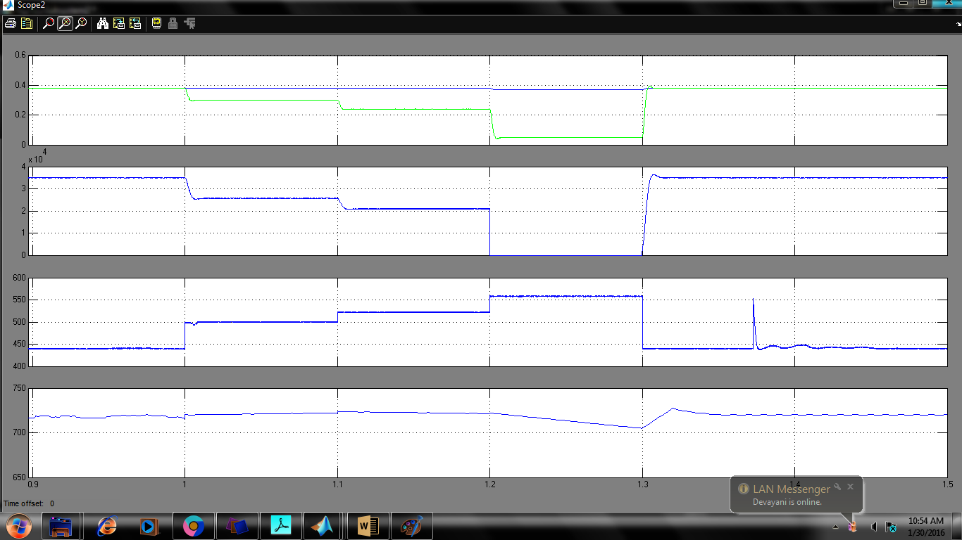

DboostPmax,Vpv,Vdc

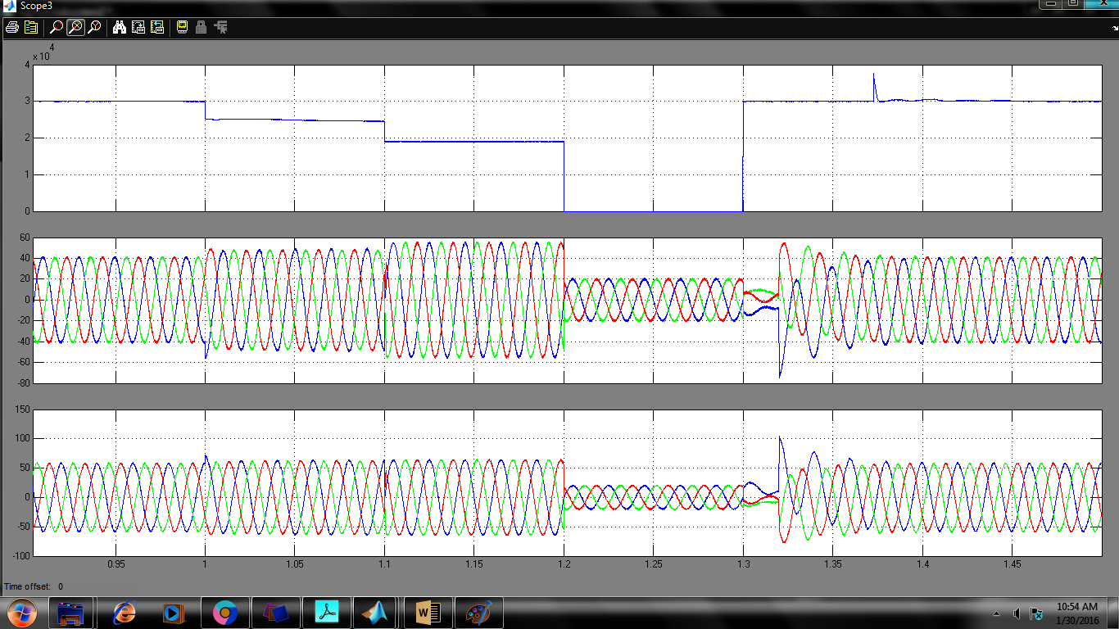

Ppv,Isabc,Ivsc

Fig. 7 System response under L-G and L-L-G faults depicting fault ride-through operation of PV inverter